

**Overload 1**

print(max(29, 5)) # output: 5

print(max([4, 5, 6])) # output: 3

print(max("Hello")) # output: "o"

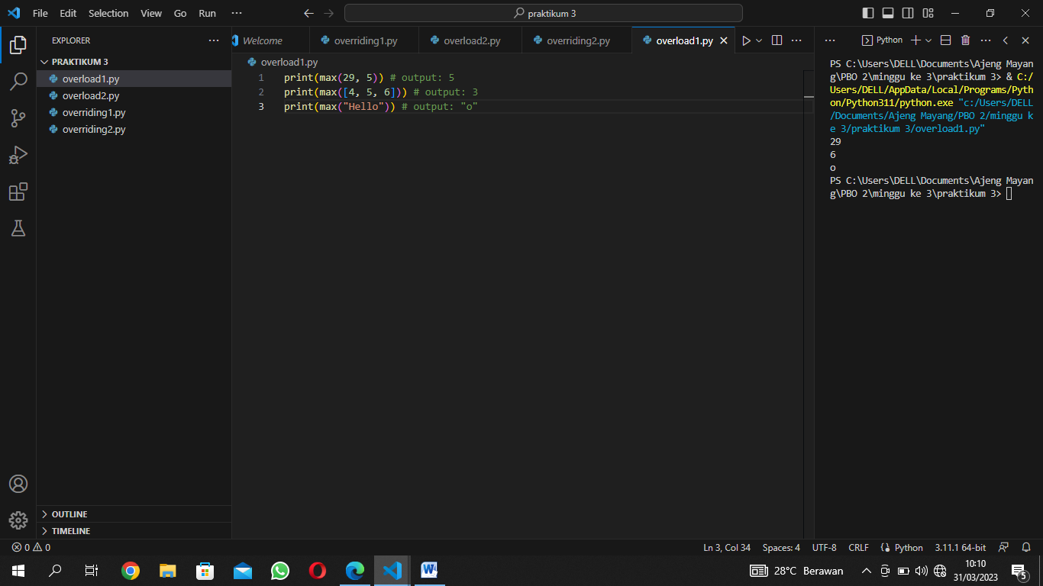

**Overload 2**

a = [29, 30, 31]

a.sort()

print(a) # output: [1, 2, 3]

b = ["c", "a", "b"]

b.sort()

print(b) # output: ["a", "b", "c"]

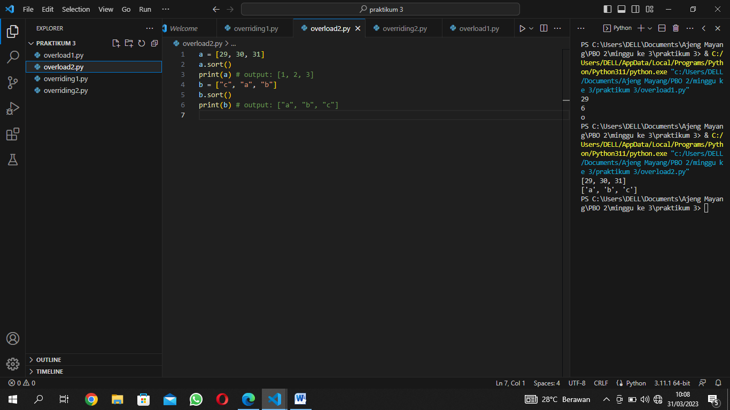

**Overriding 1**

class singa:

    def bersuara(self):

        print("rawrrr")

class kambing:

    def bersuara(self):

        print("mbee mbee")

def cetak_suara(objek):

    objek.bersuara()

singa = singa()

kambing = kambing()

cetak_suara(singa) # Output: rawrrr

cetak_suara(kambing) # Output: mbee mbee

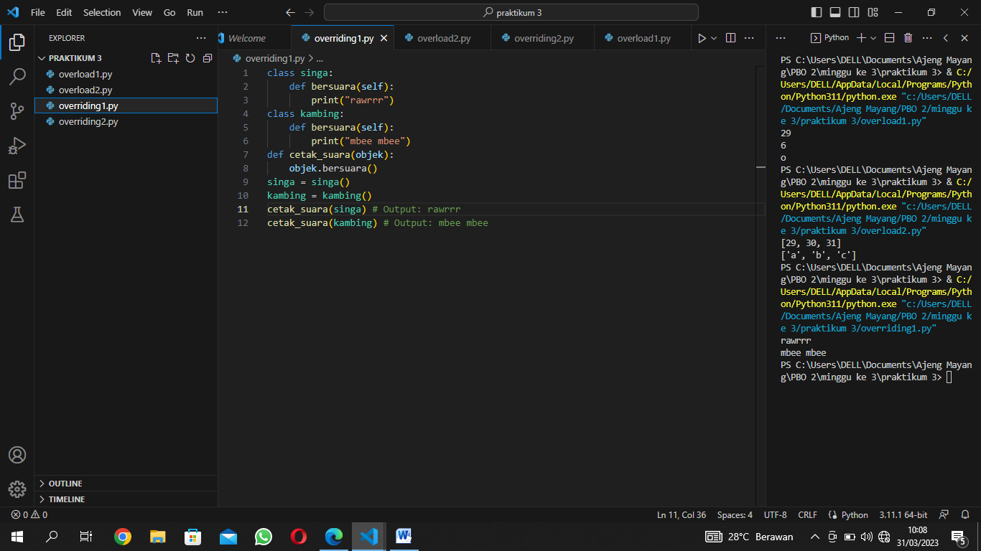

**Overriding 2**

from abc import ABC, abstractmethod

class Vehicle(ABC):

    @abstractmethod

    def start(self):

        pass

class Car(Vehicle):

    def start(self):

        print("Starting car...")

class Motorcycle(Vehicle):

    def start(self):

        print("Starting motorcycle...")

class Bus(Vehicle):

    def start(self):

        print("Starting bus...")

vehicles = [Car(), Motorcycle(), Bus()]

for vehicle in vehicles:

    vehicle.start()

